Approved by the order

of SACI «Tver Academic Regional Philharmonic»

March 27, 2024. №81-ОД

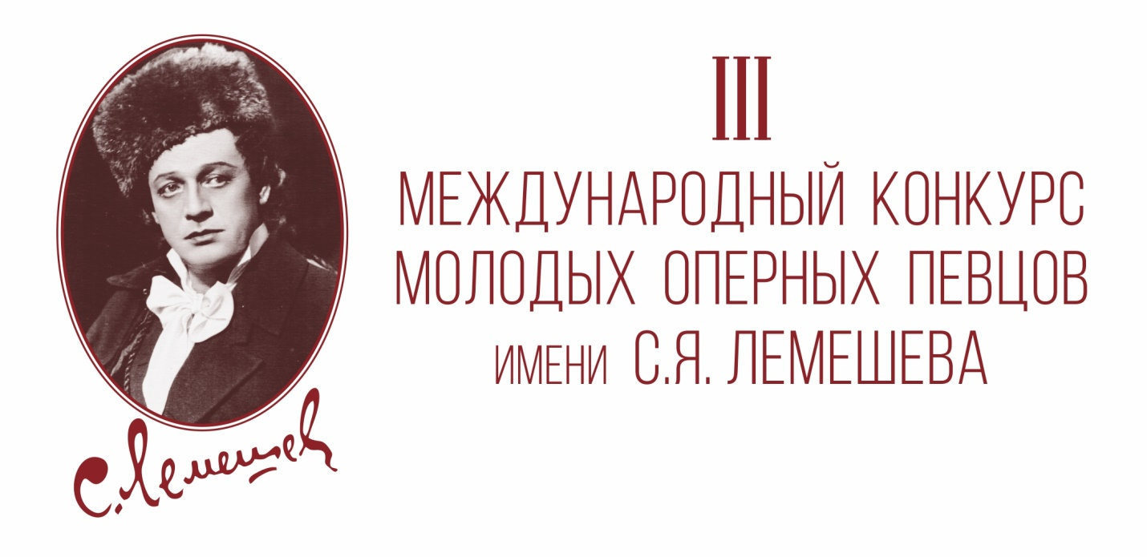

**Regulations**

**on the III International Competition for Young Opera Singers**

**named after Sergey Lemeshev**

(hereinafter Competition)

Tver, 2024

**I. Founders of the Competition**

Ministry of Culture of the Tver Region, State Autonomous Cultural Institution of the Tver Region "Tver Academic Regional Philharmonic" (hereinafter – SACI "Tver Academic Regional Philharmonic").

**II. Competition Organizer**

SACI "Tver Academic Regional Philharmonic".

The Competition is supported by the Governor of the Tver Region and the Government of the Tver Region. The Competition is a member of the Association of Music Competitions of Russia.

**III. Organizing Committee of the Competition**

For the period of organizing and holding the Competition, an Organizing Committee is created. It provides information and organizational support, advertising activities (including the mass media, Internet resources).

The composition of the Organizing Committee will be published on the official website of the Tver Academic Regional Philharmonic.

**IV. Competition Participants**

Russian and foreign performers are allowed to participate in the Competition: vocalists aged 20 to 32 who have graduated from higher musical educational institutions or currently studying there, soloists of musical theaters and philharmonic societies. The age of participants is determined at the time of the Competition opening date.

**V. Procedure, terms and venue of the Competition**

1. The Competition is held from June 29 to July 7, 2024 in the city of Tver. Participants will check into the hotel on June 28, 2024 .
2. June 29 – registration of participants, draw. (Tver, Teatralnaya Square, 1, Tver Academic Philharmonic).
3. June 30 – July 2 – first round auditions (Grand Concert Hall of the Tver Academic Philharmonic; Tver, Teatralnaya Square, 1).
4. July 3 – 4 – second round auditions (Grand Concert Hall of the Tver Academic Philharmonic; Tver, Teatralnaya Square, 1).
5. July 5 – preparation day. Rehearsals with an orchestra for the contestants who have passed in the third round.
6. July 6 – third round auditions (Grand Concert Hall of the Tver Academic Philharmonic; Tver, Teatralnaya Square, 1). At the end of the third rounds, the names of Winners and Diploma recipients will be announced.
7. July 7 – closing ceremony of the Competition and a Gala concert (Great Hall of the Tver Academic Drama Theater; Tver, Sovetskaya Street, 16).

The terms of the Competition may be adjusted depending on the number of applications received.

Competitive performances of participants must meet the program requirements of this Regulation.

**VI. Program requirements**

**I round** (no more than 15 minutes, accompanied by piano)

– Russian folk song or folk song of the participant's country.

- Aria of the XVII - XVIII centuries.

- An expanded aria by a Russian or foreign composer of the XIX - XX centuries.

**II round** (no more than 15 minutes, accompanied by piano)

- A classic romance by a Russian or foreign composer.

- An expanded aria from an opera by a Western European composer of the XIX - XX centuries.

- Aria from an opera by a Russian composer of the XIX - XX centuries.

**III round** (no more than 10 minutes, accompanied by an orchestra)

- Aria from an opera by a Russian composer of the XIX - XX centuries.

– Aria from an opera by a Western European composer of the XVIII - XX centuries.

1. The order of participants' performances is determined by drawing lots and is preserved for the entire Competition period.
2. All competitive auditions are held publicly. Entrance to the auditions and Gala concert of the Competition is carried out by ticket.

**VII. Competition Terms and Conditions**

1. The competition is held in three rounds.
2. Persons whose documents were submitted on time and in the form specified in this Regulation are allowed to participate in the First round.
3. By the decision of the Jury, no more than 50% of participants are allowed to enter the second round, and no more than 11 people are allowed to enter the third round (final).
4. Performances of participants in the first and second rounds are allowed strictly accompanied by a piano, in the third round – accompanied by an orchestra.
5. All compositions must be performed in the original language, in the original key, and by heart. Changes to the program specified in the application are not allowed. Repeating of the same compositions in different rounds is also not allowed. The Jury reserves the right to shorten the program of performances.
6. All rights to use audio and video recordings of the Competition participants' and winners' performances belong to the founders and organizer of the Competition.
7. The winners of the Competition are obligated to participate for free in the Gala Concert that will take place on July 7, 2024 in the Great Hall of the Tver Academic Drama Theater, as well as in 2 concerts of the Tver Academic Regional Philharmonic during the concert season 2024 – 2025.
8. The results of the Competition are determined by the decision of a qualified international Jury. The Jury's decision is final and cannot be reviewed.

**VIII. Competition Jury**

The participants' performances are evaluated by a qualified international Jury.

Chairman of the international Jury of the Competition – Honored Artist of Russia, People's Artist of the Republic of Bashkortostan, winner of all-Russian and international competitions, Director – Artistic Director of the Tver Academic Philharmonic Vladimir Belov.

**IX. Awarding the Competition winners**

1. Based on the decision of the Jury, the winners of the Competition are awarded the following titles: Grand Prix of the Competition, the First prize Winner, the Second prize Winner, the Third prize Winner, Diploma recipient.
2. The Grand Prix of the Competition may not be awarded by decision of the Jury.
3. Winners receive cash prizes (the amounts are indicated without deduction of mandatory taxes):

- Grand Prix – 1 prize 350 000 rubles;

- Winner of the First Prize – 2 prizes of 200,000 rubles each (male and female);

- Winner of the Second Prize – 2 prizes of 15,0000 rubles each (male and female);

- Winner of the Third Prize – 2 prizes of 100,000 rubles each (male and female);

- Diploma recipient – 4 awards.

1. The Jury reserves the right to establish special prizes and diplomas, including the prize for the best accompanist of the Competition.

**X. Submitting an application**

1. Applications for participation in the Competition are accepted from April 1 to June 12, 2024.
2. The application must be filled out in the form, posted on the Competition page on the website of the Tver Academic Regional Philharmonic, in Russian or English.
3. The documents attached to the application must be sent to the following email address: [lemeshev-konkurs@mail.ru](mailto:lemeshev-konkurs@mail.ru) marked "LEMESHEV COMPETITION":

– Completed application form;

– A scanned copy of current passport;

– Repertoire of all rounds (Word format); for the 3rd round (with an orchestra) it is necessary to give the most complete information about compositions: author, title of the opera, act, title of the aria, initial text. In the case of performing an aria with recitative, it must be indicated;

– Scanned copy of Graduate Diploma or certificate from an educational institution (for students);

– Photo, 3 MB Minimum (Studio photography only);

– A professional biography in English (Word format).

1. Upon prior request, the participant can be provided with an accompanist. In this case copies of the scores for the accompanist must be sent by June 12, 2024 to the following email address: [office lemeshev-konkurs@mail.ru](mailto:lemeshev-konkurs@mail.ru). Participants of the third roundperforming rare compositions should send the score and parts to the same email address.
2. The entry fee is 3000 rubles. Foreign participants pay an entry fee upon registration on the day of arrival.
3. Applications submitted after the specified deadline will not be accepted.
4. Expenses related to travel and accommodation of the contestants and their accompanists are borne by the contestants. If necessary, the Organizing Committee can provide assistance in booking a hotel.
5. To receive an invitation, foreign citizens wishing to participate in the Competition, must send a list of participants and accompanists with passport details to the Organizing Committee.

**XI. Contacts of the Competition Organizing Committee**

Tver Academic Regional Philharmonic

Tver, Teatralnaya Square, 1, 170100, Russian Federation

phone / fax: +7 (4822) 35-66-60

phone: +7-910-839-57-36 Tatiana

[lemeshev-konkurs@mail.ru](mailto:lemeshev-konkurs@mail.ru)